**EXAMPLE FOR ABSOLUTE AND RELATIVE XPATH**

**package** gmail;

**import** org.openqa.selenium.By;

**import** org.openqa.selenium.WebDriver;

**import** org.openqa.selenium.chrome.ChromeDriver;

**public** **class** yahoosearch {

**public** **static** **void** main(String[] args) **throws** InterruptedException {

WebDriver driver1;

System.*setProperty*("webdriver.chrome.driver","D:\\chromedriver.exe");

driver1 = **new** ChromeDriver();

driver1.get("https://in.search.yahoo.com/") ;

System.***out***.println("Page title is " + driver1.getTitle() );

// This is for relative xpath

driver1.findElement(By.*xpath*(".//*[@id='yschsp']")).sendKeys("This is relative xpath");

// This is for absolute xpath driver1.findElement(By.xpath("html/body/div[2]/div[1]/div/div/form/div/input")).sendKeys("This is Absolute xpath");

Thread.*sleep*(10000) ;

driver1.quit();

}

}

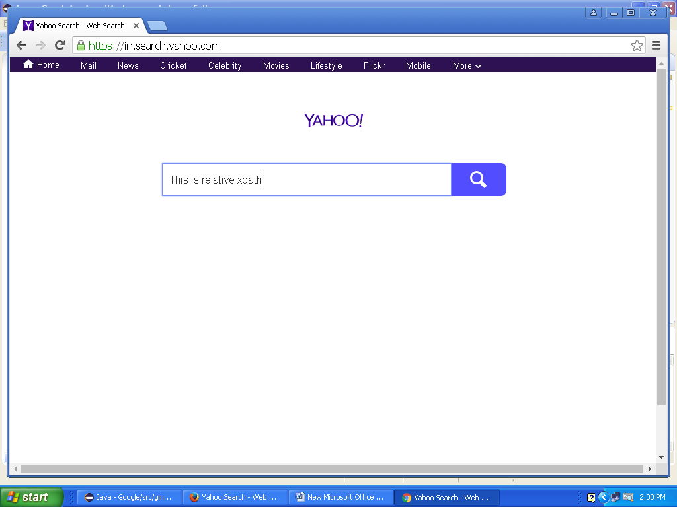

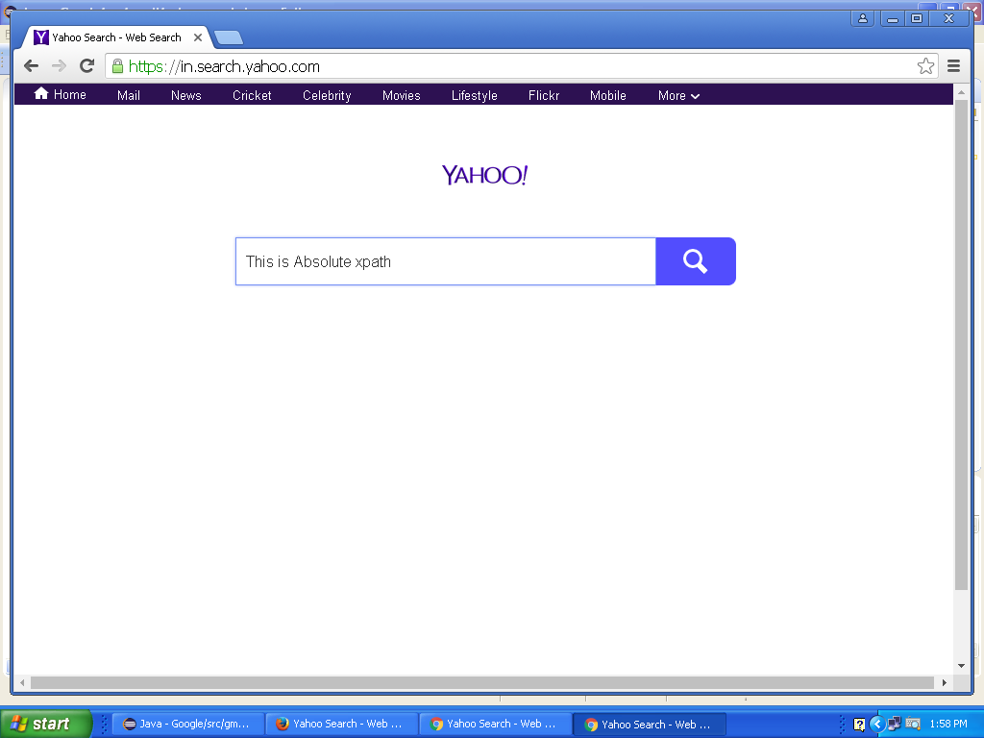

**PROGRAM TO HANDLE ALERTS**

**package** gmail;

**import** org.openqa.selenium.Alert;

**import** org.openqa.selenium.By;

**import** org.openqa.selenium.WebDriver;

**import** org.openqa.selenium.chrome.ChromeDriver;

**public** **class** alert {

**public** **static** **void** main(String[] args) **throws** InterruptedException{

WebDriver driver;

System.*setProperty*("webdriver.chrome.driver","D:\\chromedriver.exe");

driver = **new** ChromeDriver();

driver.get("http://demo.guru99.com/V4/");

driver.findElement(By.*name*("uid")).sendKeys("mngr86125");

driver.findElement(By.*name*("password")).sendKeys("AnUbUtA");

driver.findElement(By.*name*("btnLogin")).submit();

driver.findElement(By.*linkText*("Delete Customer")).click();

driver.findElement(By.*name*("cusid")).sendKeys("34940");

driver.findElement(By.*name*("AccSubmit")).click();

Thread.*sleep*(10000) ;

// Switching to Alert

Alert alert=driver.switchTo().alert();

//driver.switchTo().alert().sendKeys("I'm checking alert");

// Capturing alert message.

String alertMessage=driver.switchTo().alert().getText();

// Displaying alert message

System.***out***.println(alertMessage);

Thread.*sleep*(1000) ;

// Accepting alert

driver.switchTo().alert().accept();

Thread.*sleep*(1000) ;

}

}

**OUTPUT**

Starting ChromeDriver 2.21.371459 (36d3d07f660ff2bc1bf28a75d1cdabed0983e7c4) on port 35956

Only local connections are allowed.

Jul 04, 2017 4:38:11 PM org.openqa.selenium.remote.ProtocolHandshake createSession

INFO: Detected dialect: OSS

Do you really want to delete this Customer?

**Alert created by the page.**

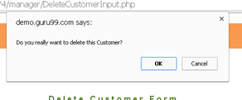

**After accepting the alert.**

